IBM – Coursera

Data Science Specialization

Capstone project - Final report

**Open A new Shopping Mall in San Jose, California**

**Introduction**

San Jose is a diverse city with many High Technology Firms and being heart of Word Famous

Innovation built on Silicon fabricated System Applications not just Products such as AI

application Robotics Internet of Things and many-others. On the other hands during weekend

of holidays there are many shoppers spent their family life on leisure activities, relax, scroll

around the shopping malls to dine and shop spent time and money in the malls.

**Business problem**

The objective of this capstone project is to analyze and select the best locations in the city of

San Jose, California to open a new shopping mall. Use Data Science methodology and machine

learning techniques such as clustering, this project intends to provide solutions to answer the

business question: In the city of San Jose, if a property developer is looking to open a new

shopping mall, where would you recommend that they open it?

**Target Audience of this project**

This project is catering to property developers and investors looking to open or invest in new

shopping malls in capital city of Silicon i.e. San Jose. This project is timely as the city and U.S.A.

is currently suffering from oversupply of shopping malls due to unprecedent Coronavirus and

malls are subjected to closing down due to the virus infections. However, when the Virus is

gone there is always need for new business investment since San Jose is such a high business

activities region deserved investment such as Malls or Business Offices.

**Data**

To solve the problem, we need the following information:

* Use of Neighborhood of San Jose California
* Latitude and longitude of those neighborhoods which is required to plot the map and use to get the venue data
* Venue Data particularly related to shopping malls and it is used to perform clustering of the neighborhood.

**Source of the data and the method to extract them**

The Wiki page (<https://en.wikipedia.org/wiki/Category:Neighborhoods_in_San_Jose,_California>)

contains the neighborhood of San Jose We will use web scraping with the help of Python Requests

and BeautiSoap packages. Then we can use Python Geocoder to obtain the Latitudes and Longitudes

of the Neighborhood. We will get the Venue Data using FourSquare API for the Neighborhood.

FourSquare provide many categories of venue data we are particularly keen on the one related to

Shopping Mall one to help us solve our problem putting forward.

This is a project using many data science using many data science skills from web scraping (Wiki)

working with FourSquare API, data cleaning, data wrangling to machine learning (K-means Clustering)

and map visualization (Folium). In next section we will present Methodology where we have taken and

data analysis, we have used with machine learning namely K-mean clustering.

**Methodology**

Firstly, we need to get the list of neighborhoods in the city San Jose, California. The list is available

in the Wikipedia page:

(<https://en.wikipedia.org/wiki/Category:Neighborhoods_in_San_Jose,_California>). We will do web

scraping using Python requests and beautifulsoup to extract the list of the neighborhoods data.

However, this is just a list of names. We need to get the geographical coordinates in the form of

latitude and longitude to use Foursquare API. To do so, we will use Geocoder package will allow us

to convert address into geographical coordinates. After gathering the data, we will populate the data

into a pandas DataFrame and then visualize the neighborhoods in a map using folium package. This

allows us to perform a sanity check to make sure that the geographical coordinates returned by

Geocoder are correctly plotted in the city of San Jose.

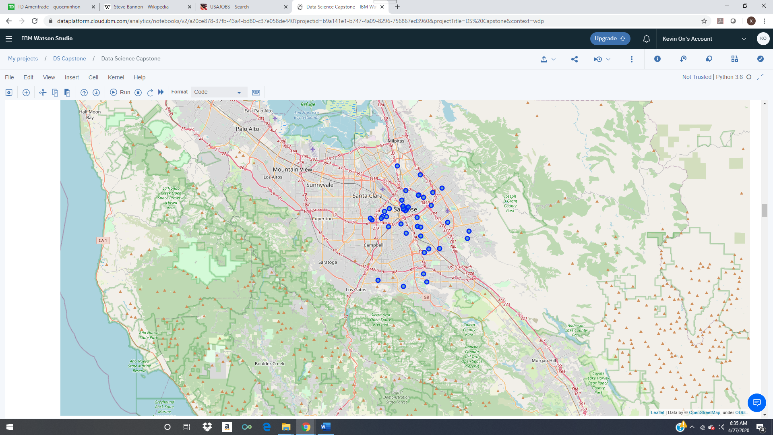

**Fig 1 : 47 neighborhoods are plotted with Folium Package.**

Next, we will use Foursquare API to get top 100 venues that are thin radius of 2000 meters.

We need to register a Foursquare Developer Account in order to obtain the Foursquare ID and

secret key. We then make API calls to Foursquare passing in geographical coordinates of the

neighborhoods in a Python loop. Foursquare will return the venue data in JSON format and we will

extract the venue name, venue category, venue latitude and longitude. With data, we can check how

many venues were returned for each neighborhood and examine how many unique categories can

be curated from all the returned venues. Then, we will analyze each neighborhood and taking the

mean of the frequency of occurrence of each venue category. By doing so, we are also preparing

the data for use in clustering. Since we are analyzing the “Shopping Mall” data, we will filter the

“Shopping Mall” as venue category for the neighborhoods.

Lastly, we will perform clustering on the data using K-means clustering. K-means clustering

Algorithm identifies K number of centroids, and then allocates every data point to the nearest

Cluster, while keeping the centroids as small as possible. It is one of the simplest and popular

Unsupervised machine learning algorithms and it is particularly suited to solve the problems for this

Project. We will cluster the neighborhoods into 3 clusters based on their frequency of occurrence

For the “Shopping Malls”. The results will allow us to identify which neighborhoods have higher

Concentration of shopping malls while which neighborhoods have fewer number of shopping malls.

Based on the occurrence of shopping malls in different neighborhoods, it will help us to answer the

Question as to which neighborhoods are most suitable to open new shopping malls.

**Results**

The results from k-means clustering show that we can categorize the

neighborhoods into 3 clusters based on the frequency of occurrence for the

“Shopping Malls”:

* Cluster 0: 30 Neighborhood with no existence of shopping malls
* Cluster 1: 7 Neighborhoods with moderate concentration of shopping malls
* Cluster 2: 10 Neighborhoods with high concentrated number of shopping malls

**Discussion**

The high concentration Cluster 1 would not be recommended to open new

shopping malls at all while the big opportunity would be in Cluster 0 while

there is no competition for foot traffics since there is no shopping malls

opened yet.

**Limitation and future research suggestions**

There are other factors such as population density and income levels of the

neighborhoods which is not available at the scope of this study which is based on mall

density or frequency of occurrence of existence of the shopping mall. In future research

those two factors should be considered in the future.

**Conclusion**

In this project we have identified the process identifying business problem, specifying

the data required, extracting and preparing the data, performing machine learning by

clustering the data into 3 clusters based on their similarities, and lastly proving

recommendations to the relevant stakeholders, property developers and investors

regarding the best locations to open a new shopping mall. To address the business

question that was raised in the introduction section, the answered proposed by this

project is: The neighborhoods in cluster 0 are the most preferable locations to open a

new shopping mall. The findings of this project will help the relevant stakeholders to

Capitalize on opportunities on high potential locations while avoiding overcrowded areas

In their decisions in opening a new shopping mall.